**Layers of The Earth Guided Notes**

**Essential Question:**How are layers of the Earth different from one another?

**Standard:**

1. Ask questions to compare and contrast the Earth’s crust, mantle, inner and outer core, including temperature, density, thickness, and composition.

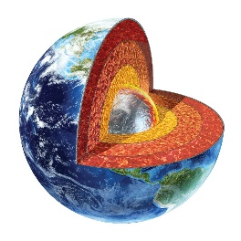**Slide 4: The Earth is made up of 4 main layers:**

* ______________________________
* ______________________________
* ______________________________
* ______________________________

**Slide 5: Crust**

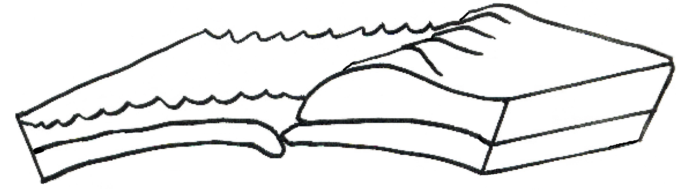

**Slide 6: Crust**

* _________________of the Earth that ranges from only ___________ in some areas of the ocean floor to ___________________ under mountains.
* _______________________________ large amounts of ___________________and________________
* ______________________________________________________: oceanic crust and continental crust
* __________________________________________________ on which the continents and oceans rest

**Slide 7: Mantle  
 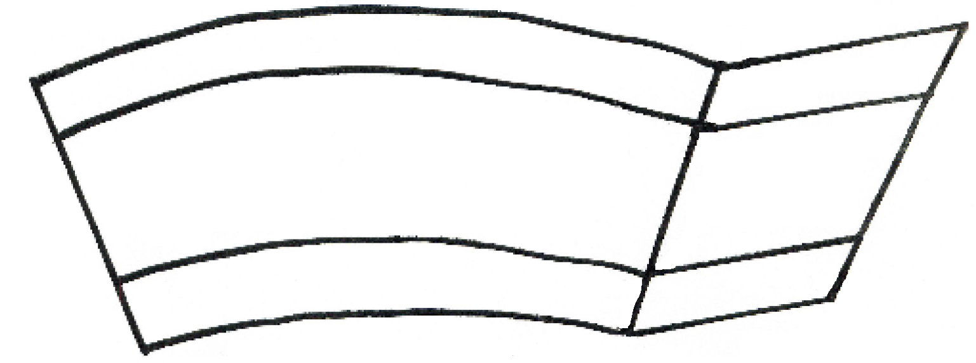** 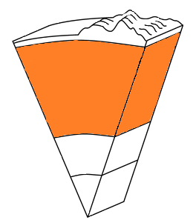

**Slide 8: Mantle**

* ______________________________________________________________ (like hot asphalt or fudge)
* ________________________________ of the Earth (making up _______________ of the Earth’s mass)
* The hot material (magma) in the mantle rises to the top of the mantle, cools, then sinks, reheats, and rises again. These ______________________________________cause changes in the Earth’s surface

**Slide 9: Core**

**Slide 10: Outer Core**

* ___________________metal that is about ___________________
* Located about _____________________________________and is about_________________________________________________
* Composed of the melted metals ___________________________



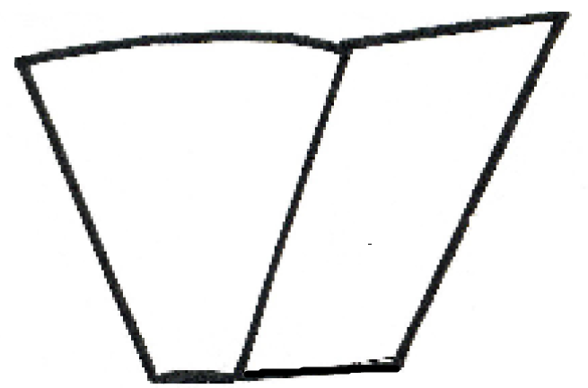

**Slide 11: Inner Core**

* ___________________ sphere composed mostly of _____________
* It is believed to be as hot as 6,650°C _________________________
* Heat in the core is probably generated by the radioactive decay of uranium and other elements
* It ____________________of the ________________ from the outer core, mantle, and crust _______________________ it tremendously

**Slide 10:**

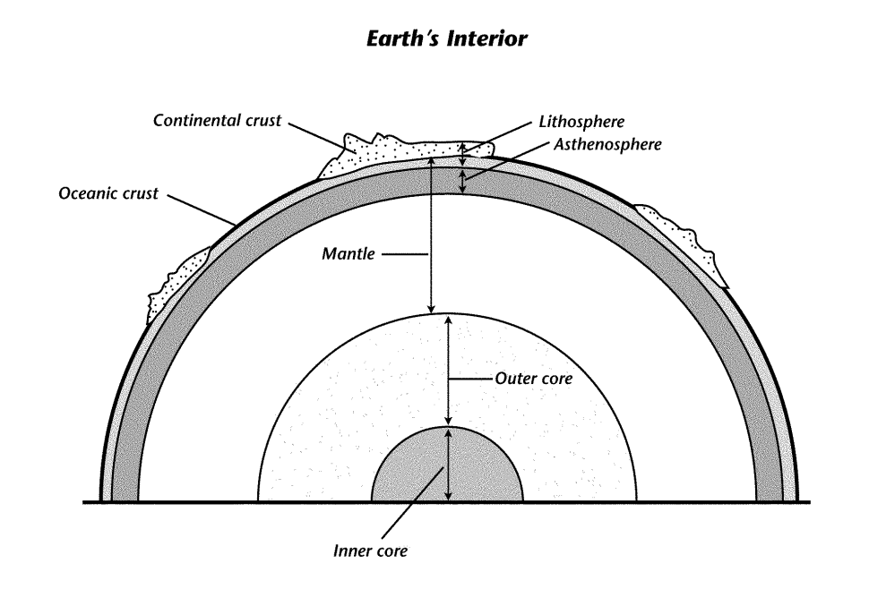

**Slide 11: The Lithosphere**

The _____________________________________________(crust and upper mantle) is divided into separate plates which move very slowly in response to the “convecting” part of the mantle.

**Slide 12:** _______________________________ increases as ___________________________________

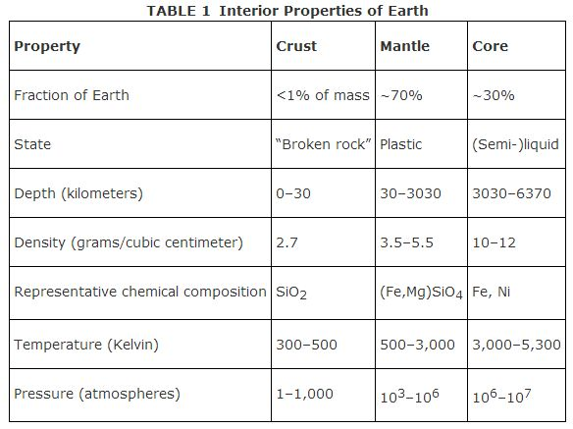

**Slide 13:**

Look at the information in the graph and table below. What’s the relationship between depth and density/pressure?

Which layer of the Earth has the greatest temperature, pressure, and density?